WEEK 6
SESSION: KMP Algorithm
TASK1: String Similarity

PROGRAM:
import java.io.*;
import java.util.*;
public class Solution {
static long findSimilarity(String s) {
int n = s.length();
int[] z = new int[n];
int l = 0, r = 0;
for (int i = 1; i < n; i++) {
if (i <= r)
z[i] = Math.min(r - i + 1, z[i - l]);
while (i + z[i] < n &&
s.charAt(z[i]) == s.charAt(i + z[i])) {
z[i]++;
}
if (i + z[i] - 1 > r) {
l = i;
r = i + z[i] - 1;
}
}
long sum = n;
for (int i = 1; i < n; i++)
sum += z[i];
return sum;
}
public static void main(String[] args) throws IOException {
BufferedReader br = new BufferedReader(new InputStreamReader(System.in));
int t = Integer.parseInt(br.readLine().trim());
while (t-- > 0) {
String s = br.readLine().trim();
System.out.println(findSimilarity(s));
}
}
}
OUTPUT:
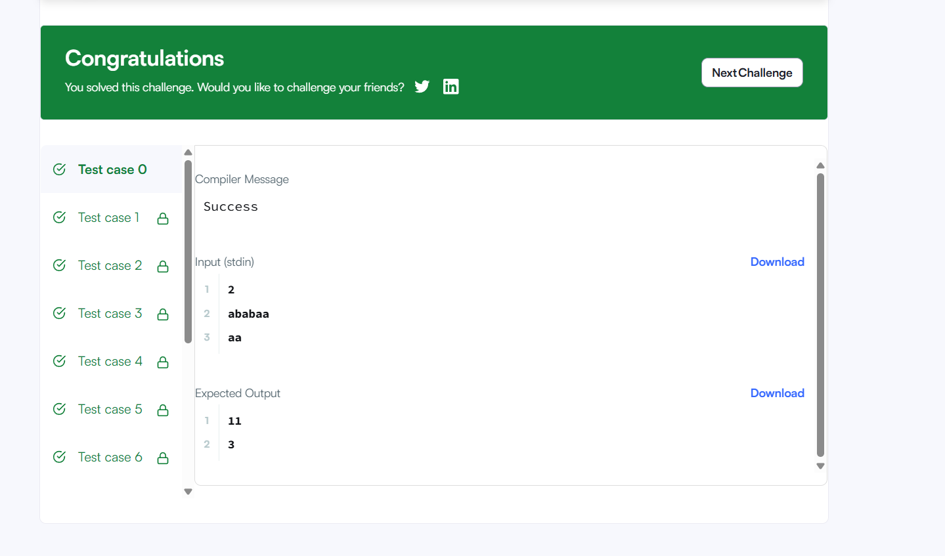

TASK2: Repeated Substring Pattern
PROGRAM:
class Solution {
public boolean repeatedSubstringPattern(String s) {
return (s + s).substring(1, 2 * s.length() - 1).contains(s);
}
}
OUTPUT:
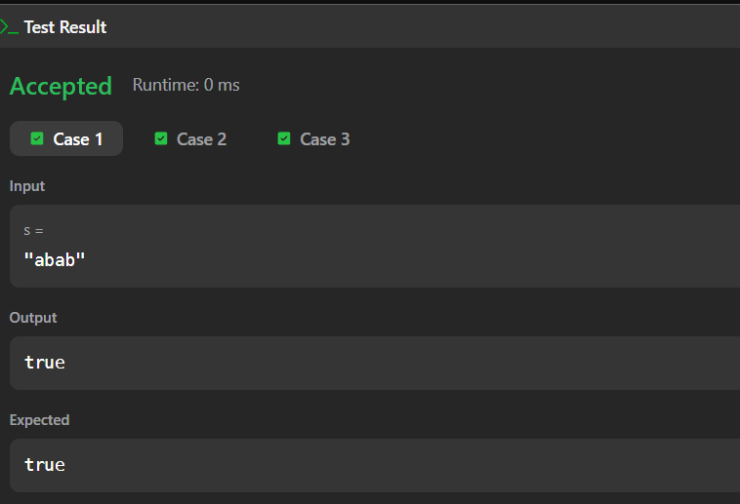
SESSION 2: KMP Applications
TASK3: Two string
PROGRAM:
import java.io.*;
import java.util.*;
public class Solution {
public static String twoStrings(String s1, String s2) {
boolean[] seen = new boolean[26];
for (char c : s1.toCharArray())
seen[c - 'a'] = true;
for (char c : s2.toCharArray()) {
if (seen[c - 'a'])
return "YES";
}
return "NO";
}
public static void main(String[] args) throws IOException {
BufferedReader br = new BufferedReader(new InputStreamReader(System.in));
int t = Integer.parseInt(br.readLine());
while (t-- > 0) {
String s1 = br.readLine();
String s2 = br.readLine();
System.out.println(twoStrings(s1, s2));
}
}
}
OUTPUT:
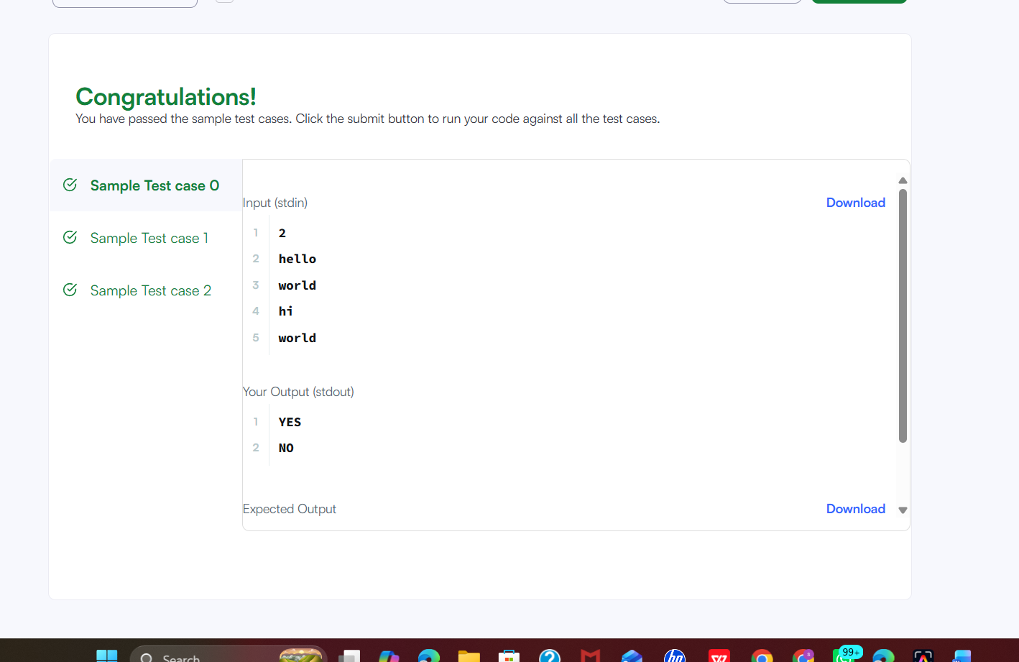

TASK4: Rotate string
PROGRAM:
class Solution {
public boolean rotateString(String s, String goal) {
return s.length() == goal.length() && (s + s).contains(goal);
}
}
OUTPUT:
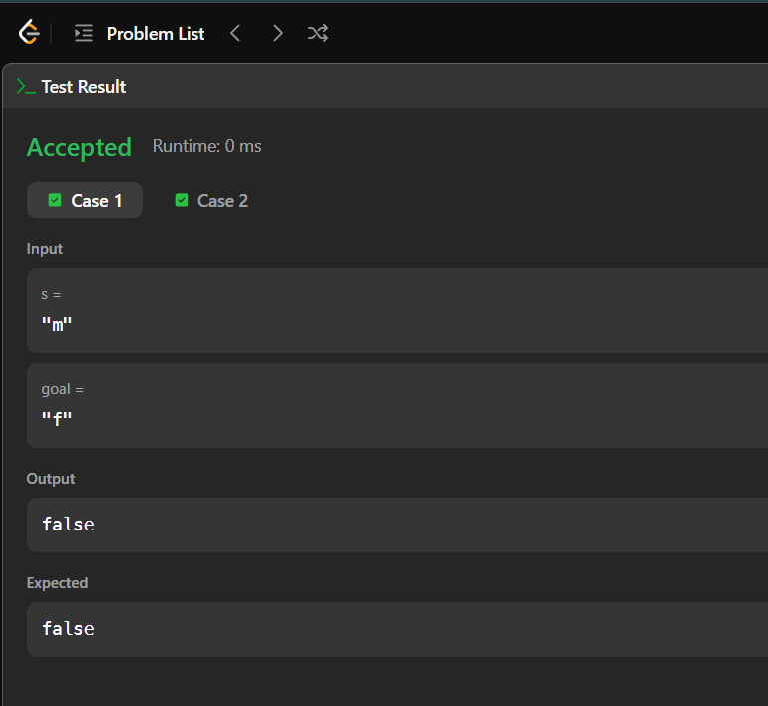
SESSION 3: Boyer Moore Algorithm
TASK5: mars exploration
PROGRAM:
import java.io.*;
public class Solution {
public static int marsExploration(String s) {
int count = 0;
String pattern = "SOS";
for (int i = 0; i < s.length(); i++) {
if (s.charAt(i) != pattern.charAt(i % 3))
count++;
}
return count;
}
public static void main(String[] args) throws IOException {
BufferedReader br = new BufferedReader(new InputStreamReader(System.in));
String s = br.readLine();
System.out.println(marsExploration(s));
}
}
OUTPUT:
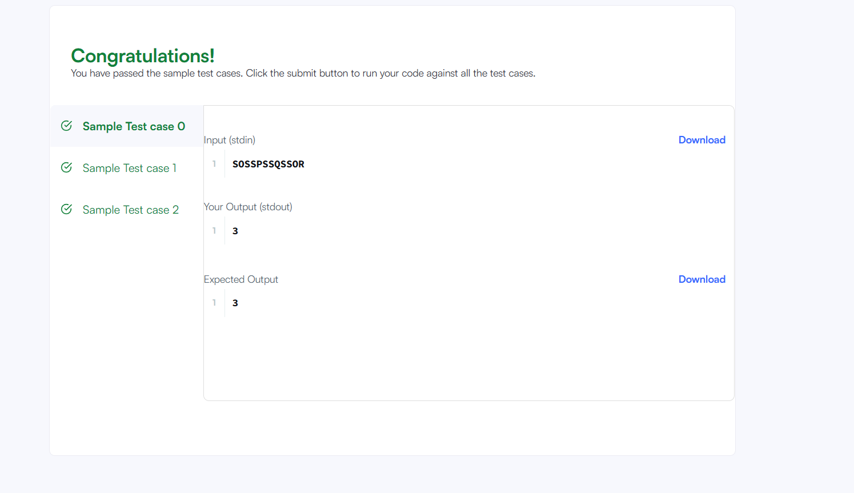

TASK6: find all anagrams in a string
PROGRAM:
class Solution {
public List<Integer> findAnagrams(String s, String p) {
List<Integer> ans = new ArrayList<>();
int[] count = new int[26];
for (char c : p.toCharArray())
count[c - 'a']++;
for (int i = 0; i < s.length(); i++) {
count[s.charAt(i) - 'a']--;
if (i >= p.length())
count[s.charAt(i - p.length()) - 'a']++;
if (i >= p.length() - 1 && isZero(count))
ans.add(i - p.length() + 1);
}
return ans;
}
private boolean isZero(int[] count) {
for (int n : count)
if (n != 0)
return false;
return true;
}
}
OUTPUT:
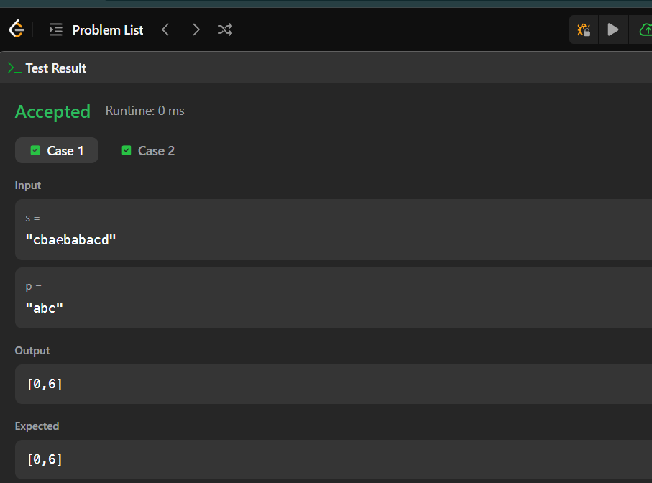
SESSION4: Palindrome Techniques
TASK7: palindrome index
PROGRAM:
import java.io.*;
public class Solution {
public static int palindromeIndex(String s) {
int left = 0, right = s.length() - 1;
while (left < right) {
if (s.charAt(left) != s.charAt(right)) {
if (isPalindrome(s, left + 1, right))
return left;
if (isPalindrome(s, left, right - 1))
return right;
return -1;
}
left++;
right--;
}
return -1;
}
static boolean isPalindrome(String s, int left, int right) {
while (left < right) {
if (s.charAt(left) != s.charAt(right))
return false;
left++;
right--;
}
return true;
}
public static void main(String[] args) throws IOException {
BufferedReader br = new BufferedReader(new InputStreamReader(System.in));
int q = Integer.parseInt(br.readLine());
while (q-- > 0) {
String s = br.readLine();
System.out.println(palindromeIndex(s));
}
}
}
OUTPUT:
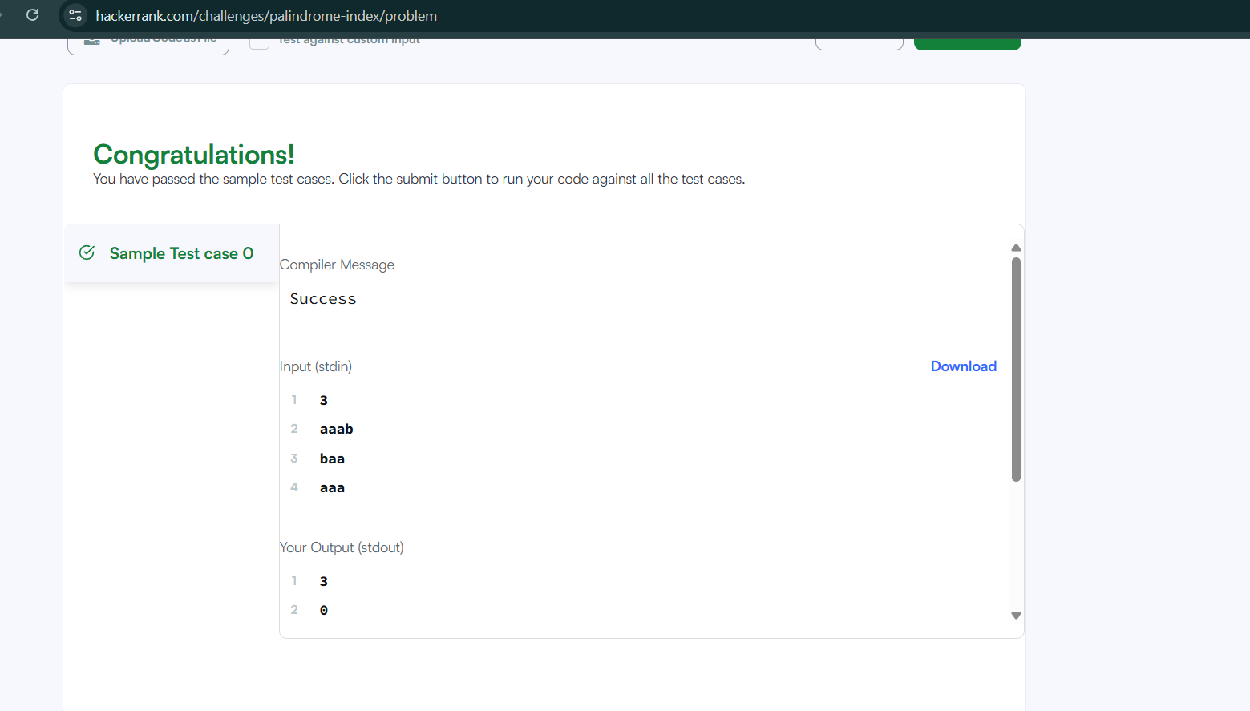

TASK8: find the index of the first occurrence in a string
PROGRAM:
class Solution {
public int strStr(String haystack, String needle) {
return haystack.indexOf(needle);
}
}
OUTPUT:
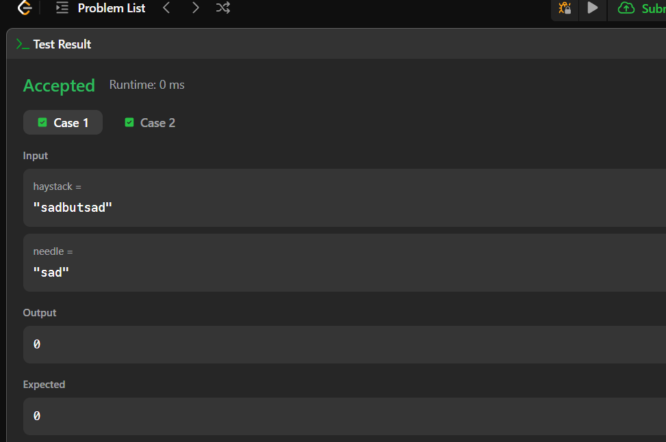

SESSION5: Manacher Algorithm for finding longest palindromic substring
TASK9: longest palindromic substring
PROGRAM:
class Solution {
public String longestPalindrome(String s) {
int start = 0, max = 1;
for (int i = 0; i < s.length(); i++) {
int len1 = expand(s, i, i);
int len2 = expand(s, i, i + 1);
int len = Math.max(len1, len2);
if (len > max) {
max = len;
start = i - (len - 1) / 2;
}
}
return s.substring(start, start + max);
}
private int expand(String s, int l, int r) {
while (l >= 0 && r < s.length() && s.charAt(l) == s.charAt(r)) {
l--;
r++;
}
return r - l - 1;
}
}
OUTPUT:
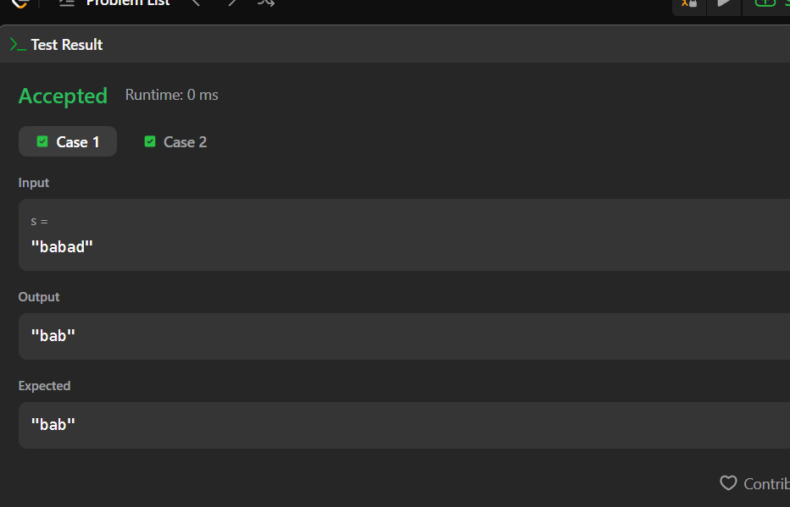
TASK 10: circular palindrome
PROGRAM:
import java.io.*;
public class Solution {
static int longestPalindrome(String s) {
int max = 1;
for (int i = 0; i < s.length(); i++) {
max = Math.max(max, expand(s, i, i));
max = Math.max(max, expand(s, i, i + 1));
}
return max;
}
static int expand(String s, int l, int r) {
while (l >= 0 && r < s.length() &&
s.charAt(l) == s.charAt(r)) {
l--;
r++;
}
return r - l - 1;
}
public static void main(String[] args) throws IOException {
BufferedReader br = new BufferedReader(
new InputStreamReader(System.in)
);
int n = Integer.parseInt(br.readLine());
String s = br.readLine();
for (int k = 0; k < n; k++) {
String rotated = s.substring(k) + s.substring(0, k);
System.out.println(longestPalindrome(rotated));
}
}
}
OUTPUT:
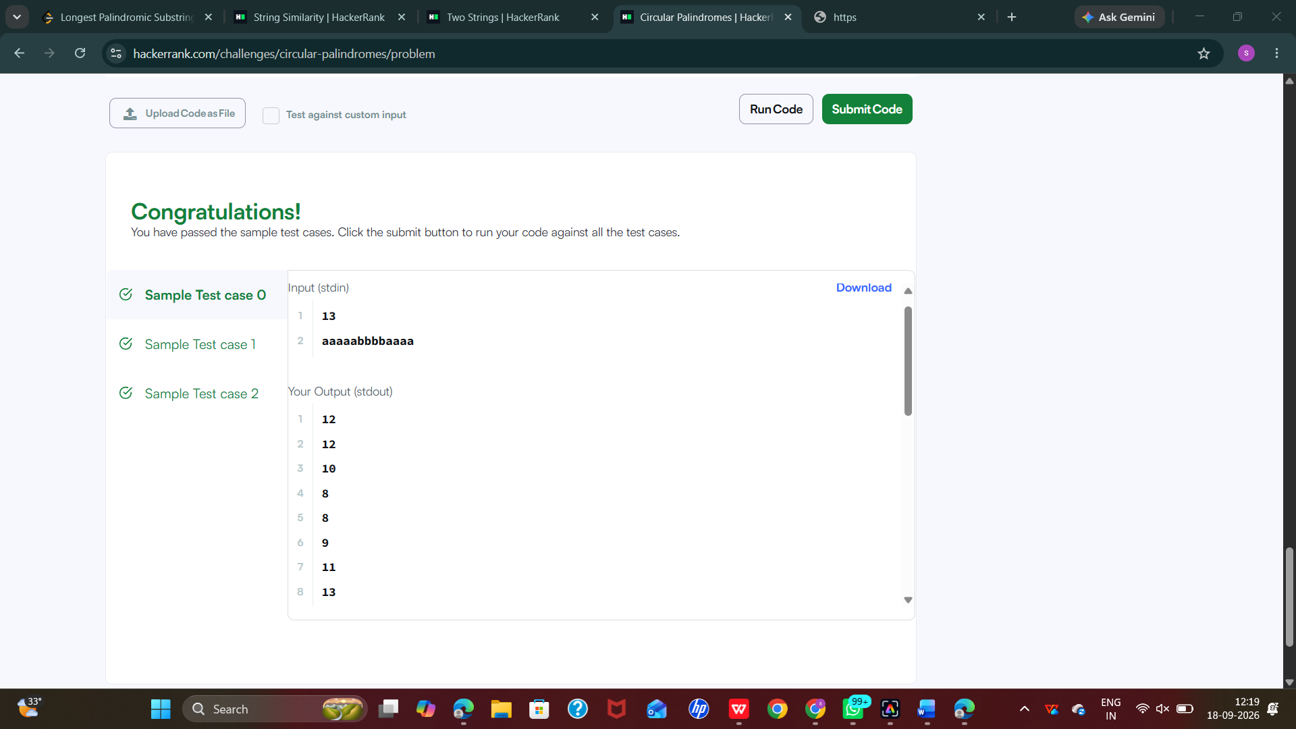

RESULT: Thus the week 6 session has completed successfully.

